|  |
| --- |
| **Knowledge Capture Document – Project Costing** |
| Author: Bijay Tripathy |
| Date: 25-Oct-2016 |



**Session Log:**

|  |  |  |  |  |
| --- | --- | --- | --- | --- |
| **Sr. No** | **Session Date & Time** | **Duration** | **HSB SME(s)** | **Knowledge Recipient(s)** |
| 1 | 10/20/2016  10:00 am | 40 mins | Matteo Edwards, Gopal Mirani | Bijay Tripathy, Bipul Sharan, Neha Garg, Paritosh Barle |
| 2 | 10/24/2016  10:00 am | 1 Hr | Matteo Edwards, Gopal Mirani | Bijay Tripathy, Bipul Sharan, Neha Garg, Paritosh Barle |
| 3 | 10/25/2016  10:00 am | 1 Hr | Matteo Edwards, Gopal Mirani | Bijay Tripathy, Bipul Sharan, Neha Garg, Paritosh Barle |
| 4 | 10/26/2016  10:00 am | 30 mins | Matteo Edwards, Gopal Mirani | Bijay Tripathy, Bipul Sharan, Neha Garg, Paritosh Barle |
| 5 | 11/03/2016  10:00 am | 1 hr | Matteo Edwards, Gopal Mirani | Bijay Tripathy, Bipul Sharan, Neha Garg, Paritosh Barle |

**Record of Release:**

|  |  |  |  |  |  |
| --- | --- | --- | --- | --- | --- |
| Version No. | Modified By | Reviewed By | Authorized By | Release Date | Modifications Done |
| 0.1 | L&T Team |  |  | 11/082016 | Initial draft |

**Table of Contents**

Purpose of the Document 4

1 Module Overview 5

2 Setup and Configuration 6

3 Business Process 6

4 Interface 16

5 Reports / Daily Batch 17

6 Queries 21

7 Glossary 21

# Purpose of the Document

This document has been designed to capture Project Costing module information in the existing PeopleSoft Financials 9.1 system in HSB. It includes existing processes, Interfaces, customization and expectations from PeopleSoft Project Costing system.

This document can be used as a snapshot of existing business processes, its mapping with PeopleSoft as of the date. Information captured in this document would facilitate support team to be in sync with the system they would support in the future.

# Module Overview

HSB uses PeopleSoft Project Costing module to track and analyze the cost of services provided to the customer. It is also used to maintain allocation within PeopleSoft. Currently, Project Costing module is integrated with Billing, Contracts, General Ledger, SAP HR and Lotus Notes Genesys application.

**Data flow diagram**

***Project Costing- Data Flow***

**Lotus Notes / Genesys Time & Expense Tracking**

**General Ledger/ Budgeting**

**Data Warehouse PC Reporting**

**Project Costing**

**Contracts**

**MRAm SAP HR & Payroll**

**Legend**

: Internal Inbound and Outbound

: External Inbound

: External Inbound and Outbound

# Setup and Configuration

* Currently, HSB has configured two Business Unit for Project Costing module: GPHSB and ITHSB.
  + GPHSB BU is used to track the projects related to the services provided by HSB Engineers to Customers which are originally entered in Lotus Notes.
  + ITHSB BU is used to maintain HSB internal IT projects. These project are used to track down IT efforts in conjunction with PeopleSoft time track module.
* For all the policy coming from Lotus notes, HSB Contract number is defaulted to ‘GEN0000007001’.

Please find attached below document for other set up and configuration:



# Business Process

* **Lotus Notes to HSB Custom Interface Records**

HSB has a schedule SQR process ‘*HSBLOTUS’* which will read the input files from Lotus notes, process it and upload the data to HSB custom interface table *HSB_PC_INT1* of PC module

* **HSB Custom Interface Table to PC Interface table**

HSB has a custom job ‘PC COBOL PC PREP BATCH’ for loading PC Interface table. This job is scheduled in tidal and it reads the data from HSB custom records and insert it in PC interface records.

* **PC Interface table to PC main tables**

The Job ‘PC Project Interface’ is scheduled in Tidal and it loads the project costing main tables with the data from PC interface table. This includes Project data, Resource data and Activity data.

* **PC to Billing**

The process ‘*PC_PC_TO_BI’* pulls the data from the Project Costing module and load it in the Billing interface table

**Project Allocation**

HSB has Project Allocation only for *GPHSB.* Allocation process starts by deleting prior data from Staging table (HSB_PC_ALLOC). PSFT Tech Team will do the required Set up for allocation after receiving mail from Dave (David_Thibodeau@hsb.com).

**Step 1:**

**Process Name:** HSB PC Fiscal Year- HSBPCALD.sqr

**Run Control ID:** CLEANALLOC

This process is scheduled to run every month.

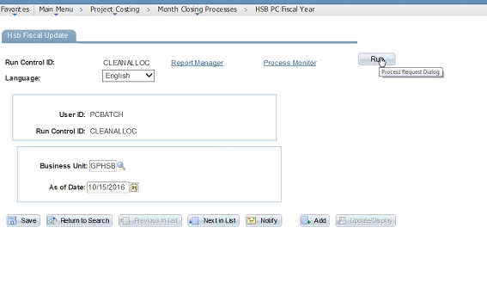

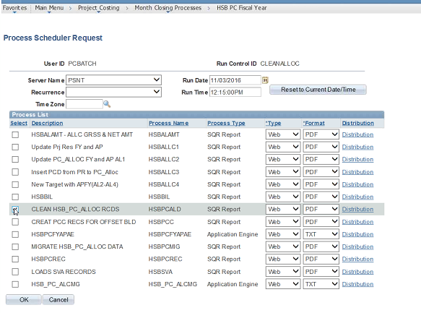

**Step 2**

**Request Allocation Set Up**

All the allocation processes are scheduled in Tidal scheduler under the Job PC_ALLOCATION.

**Process Name:** Allocation Request- FS_ALLOC

**Run Control ID:** ALLOC1

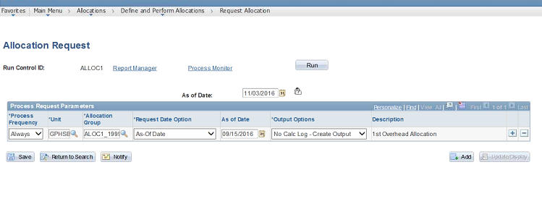

**Run Control ID:** ALLOC2

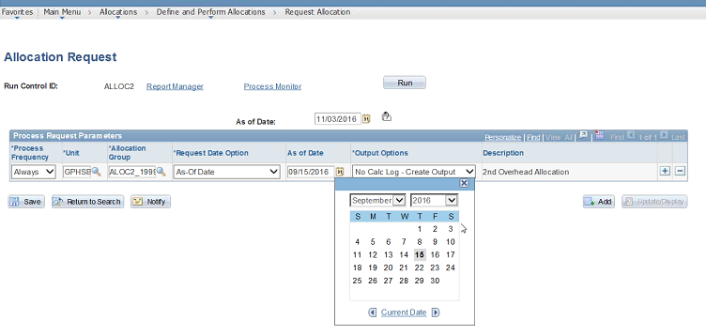

**Run Control ID:** ALLOC3

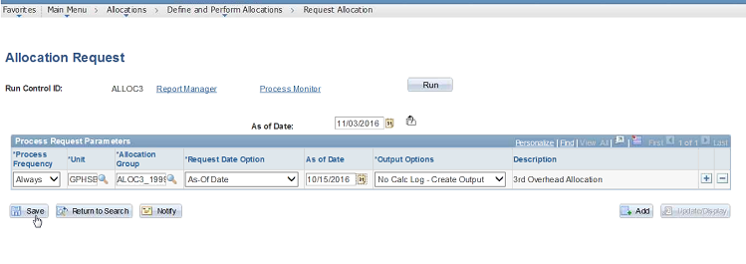

**Run Control ID:** ALLOC4

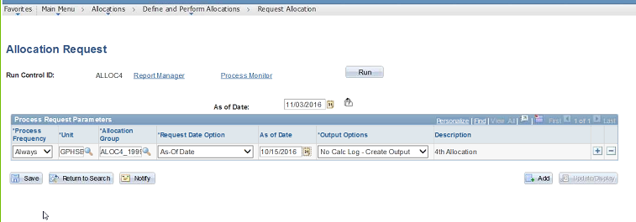

**Step 3**

**Process Name:** **HSB PC Fiscal Year** – HSBALLC1.sqr /HSBALLC2.sqr/ HSBALLC3.sqr/ HSBALLC4.sqr

**Run Control ID:** UPDT_FISCAL

This is an SQR process. It selects the fiscal year and Accounting period for the records and update it in Project Resource table based on Accounting date.

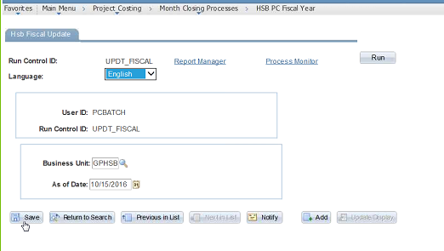

**Step 4**

**Process Name:** **Load to GL Prep process – HSBTOGL.sqr**

**Run Control ID:** HSBTOGL1

This is an SQR process and it reads the GL data from file and insert it into table. The value in fields Accounting Date and Load File (Current month) is manually updated.

This SQR selects allocation related rows from PS_HSB_PC_ALLOC table and creates a flat file that can be loaded in GL system. Records selected is based on Business Unit, Accounting Date, Analysis types of ‘AL1’, ‘AL2’, ‘AL3’,’AL4’ and ‘PCD’ and Accounts that exists in Tree and Node specified on Run control page.

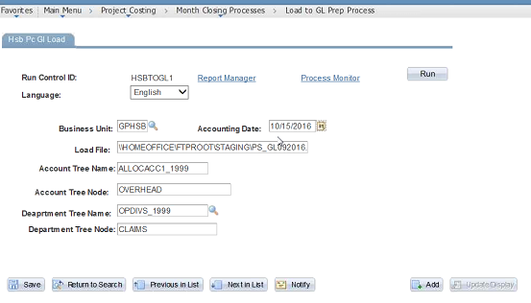

**Step 5**

**Process Name:** **PC GL Feed - HSBGL002.sqr**

**Run Control ID:** GL002

Just copying and creating new file with some changes in selected data.

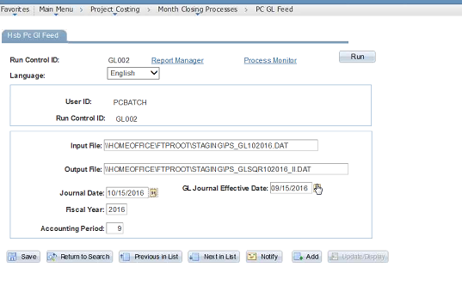

**Process Name:** **PC GL Feed - HSBGL0CT.sqr**

**Run Control ID:** GL002CT

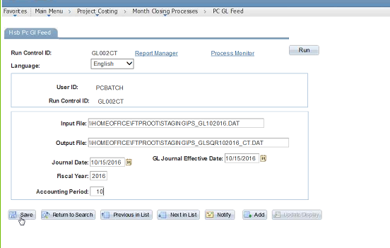

**Step 6**

**Process Name:** **HSB PC Fiscal Year - HSB_PC_ALCMG**

**Run Control ID:** MIGRATENEWAPP

This process is selecting data from HSB_PC_ALLOC table and inserts it into HSB_PC_ALLOC99 table based on certain criteria.

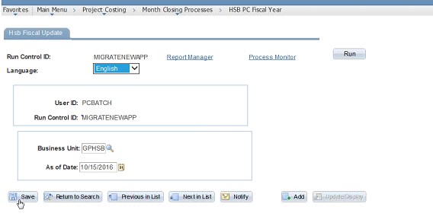

**Process Name:** **Load to GL Prep Process – HSBSVCRT.sqr/** **HSBSVAL2.sqr**

**Run Control ID: DEPTRATE**

This process is for Department role upgrade. This is an SQR process and it reads the tree data, process it and update it in some record.

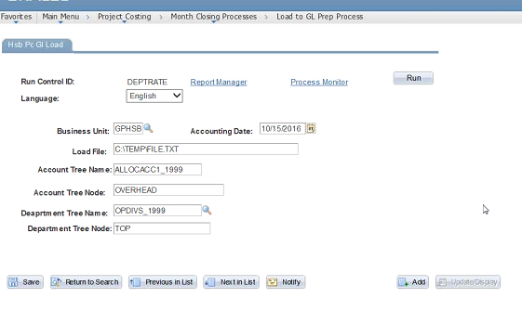

**Process Name:** **Load SVA records – HSBSVA.sqr**

**Run Control ID: SVARUN**

This process selects data from PS_PROJ_RESOURCE table, Process it and updates the resource status field in PS_PROJ_RESOURCE table.

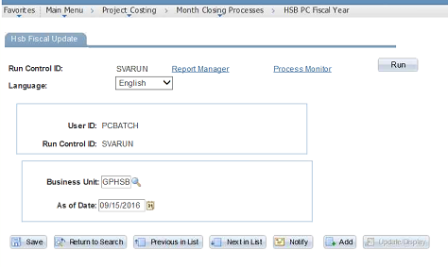

**Process Name:** **Create allocation Trigger file – HSBPCTRG.sqr**

**Run Control ID: SVARUN**

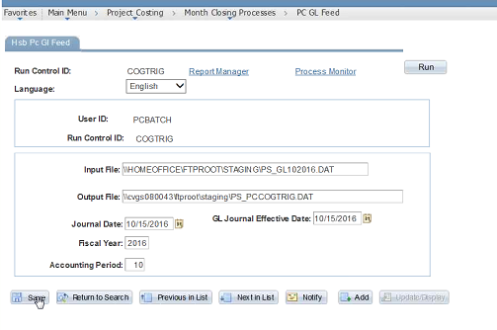

**Scheduled Jobs in Tidal for allocation**

Most of the PC allocation job are scheduled in TIDAL. The job is file dependent & kick off when business team run the process to create a trigger file for the job.

PC_ALLOCATION

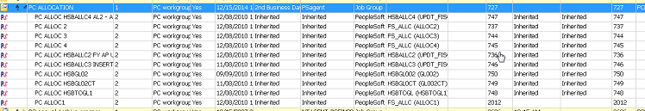

PC RATE/SVA CREATION

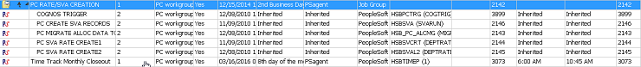

# Interface

**Lotus Notes / Genesys**

This is a Time and Expense feed for the HSB Inspectors and users. In lotus notes the users enter their billable and non-billable time. The Activities performed by the Inspectors are also tracked along with the Customer data for which it is done. This includes information like Project ID, Activity ID, Customer, Location and Rates (Hourly Rate, Day Rate, Intermediate Rate and Annual Rate). All this information is in Sync between Project Costing (PC) module and Lotus Notes.

There are few jobs in PC module which will check if Project ID is available in the system. If not, HSB has a batch process which will create the new Project ID. Sometimes, applicable rates are tagged corresponding to the Customer. The process PC Prep reads data and apply the rates. For example, if it’s an hourly project then hourly rates will be applied.

Lotus Notes sends the files to PeopleSoft. PSFT system reads these files and loads the data to PC records. This process runs during day time. The batch process in PC module starts at night and it process this data. All the PSFT rules are applied and data is validated before inserting it into Interface records of PC like Proj Interface, Proj Activity, Proj Resource.

**ADP Payroll**

The PC module has Employee data that comes through SAP HR interface. All HR data is maintained in SAP Munich system and this data is sent to HR bolt on module in PeopleSoft. The Bolt on HR module sends this data to Lotus Notes Genesys and other internal module.

The Project Resource data received in PC module from the Lotus notes system is validated against the Employee data received from the SAP HR system.

**General Ledger**

This is a two way interface. The GL module sends data to PC module and this is a monthly activity. The data includes Statistical rates which are used during the monthly closing Allocation cycle. There are Jobs in PC module which uses this data to perform the allocation activity and sends back data to GL module to complete the monthly cycle.

**Cognos / PC Reporting**

Cognos system pulls data from PC module. This is a weekly activity. The Cognos team maintains this interface and PSFT Tech team gets queries and issues related to data

**Billing Interface**

The process ‘PC_PC_TO_BI’ pulls the data from the Project Costing module and load it in the Billing interface table. It updates the interface BI table with Project and Resource data. The BI interface table is loaded with the Project Resource data that has an Analysis type as ‘ENG’ and BI Interface Status =‘N’. Once the data is pulled its status is changes to ‘D’ for done in PC module. The user can change this status back to ‘N’ if there is any change in the project data.

# Reports / Daily Batch

**Lotus Notes for Contract**

Lotus Notes system produces two files with the Contract details that has to be uploaded in PeopleSoft system. One for IIC & other for CT. The format of the file is same as required by PeopleSoft system and therefore, formatting changes are not required.

The data from lotus application includes following:

* Lotus Contract Number
* Cost Centre
* Line of Business
* Transaction date
* Policy Number

HSB has a schedule process which will read these files, process it and upload data to staging table *HSB_PC_INT1* of PC module. The name of this process is *HSBLOTUS* and it is an SQR process. It is scheduled to run at 2.00 PM every day.

**Path for input file**

* HSBCT**-** *\\PSOFTDEV85\FTPROOT\STAGING\PCPREP_HSBCT.TXT*
* IIC **-** *\\PSOFTDEV85\FTPROOT\STAGING\PCPREP_HSBII.TXT*

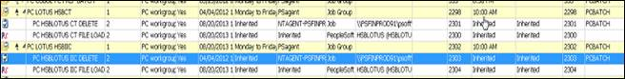

Once the data is uploaded in interface table, another process runs and delete these file. This process runs for both, IIC and CT. The folder path for batch file are:

* HSBCT - *PSFINPROD91\psoft\fscm91\user\lotus_HSBCT_delete.bat*
* IIC - *PSFINPROD91\psoft\fscm91\user\lotus_HSBII_delete.bat*

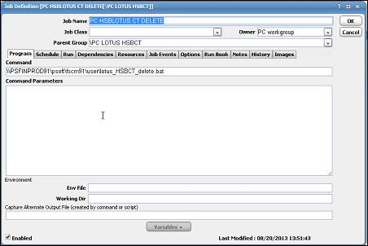

Point of contact for Lotus notes is Ahren (ahren_niles@hsb.com)

**Project Status, Activity Status and Resource Update**

There are three jobs for updating the value for project Status, Activity Status and Resource Data: ‘HSBPC100AE’,‘HSP2000’ and ‘HSP3000’. All these processes are scheduled to run at 6.30 PM.

* **HSBPC100AE**: It is an Application Engine process which analyzes the Project data to find out the Project availability in PeopleSoft system. If the Project is available, then it will assign value ‘B’ in the record (HSB_ADDR_STATUS) HSB_PC_INT1 and that record is not inserting it into main tables. If the Project is not found in PeopleSoft then the value ‘I’ is assigned and it is inserted in main table.
* **HSP2000**: This is a COBOL process. The processing of HSB2000 is similar to HSB1000. HSB2000 checks for combination of Project Status and Activity Status. Based on the availability of this combination, data insertion is performed.
* **HSP3000**: This is a COBOL program. It reads all the Project Resource data and business logic is applied. The updated data is inserted into the Interface Project Resource table.

In case of any error in above mentioned process the Status value is updated with ‘E’.

**HSBPCDES**

This process reads the Description data entered by Inspectors and upload it into HSB_PC_BI_DESCR table which is linked to PS_INTFC_PROJ_RES table. In billing module, it goes to BI_NOTES table.

**Project Interface (PC_PC_TO_BI/PC_INTFEDIT/PC_INTF_GEN)**

This Job is scheduled in Tidal and it has four process in it. The first process is for Project Gen \Creation. This process puts the interface project data into project costing tables. The next processes are for Project Activity creation and Project Resource upload.

* **PC_PC_TO_BI**
* **PC_INTFEDIT:** This process Edits and loads the data from INTFC_PROJ_RES table to PROJ_RES table.
* **PC_INTF_GEN:** This process loads Project and Activity data to Project Costing tables**.**
* **HSBPCSPECAE- Interface Special Job-BLE stuff:**

This is an Application Engine program and it deals with Brazilian Contracts. It reads the contract data that comes to PC module and it extracts the details like Owner, Cost Center for the person doing it etc. This process selects the Contracts for Brazil that needs to be priced. The selected data is updated with the Job code as ‘BLE’ and contract data in *PROJ_RESOURCE* table. This is done before the data comes to project costing module.

In PC module, when pricing engine runs it reads the Job code as ‘BLE’ and apply the pricing template accordingly. The Project costing records is updated with the right pricing data based on Job code.

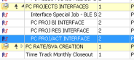

**PC Buc Clean**

This is for the interface between PSFT system and Cognos application. We are sending Buc Code to Cognos system for validation purpose. If the Buc Code is found to be invalid the Cognos system will send back the data to PSFT system for correction. There are following four processes under this job:

* **PC BUC CLEAN A (HSBPCBUCAE)**

This is an Application Engine program. This process updates the data in staging records that needs to be send to Cognos.

* **BUC COG TRIGGER FILE**
* **PC BUC CLEAN2 (HSBPCBUC2AE)**

This is an Application Engine program. This process reads the updated Buc Code (In case of invalid Buc Code) data sent by Cognos system and update it into Staging record.

* **BUC TRIGGER FILE DELETE**



**HSBPC100**

This is an SQR process and it perform validation for policy number. It reads the table that Cognos system updates and validate policy number before putting it in Project Costing records.

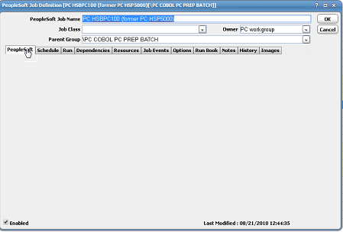

**HSB_PC_UTILITY_GBL- Archiving Process**

HSB has an Application Engine program as ‘HSBPCARCHIVE’ to perform archiving in PC module. This an annual activity and it is done by PSFT Tech Team. First, Interface Processing Option is selected as **Load Trans**. This will load data to ‘FARC’ database. Once we receive confirmation from FARC database team on this next time Interface Processing Option is selected as **Del Trans** to delete the data from project resource table.

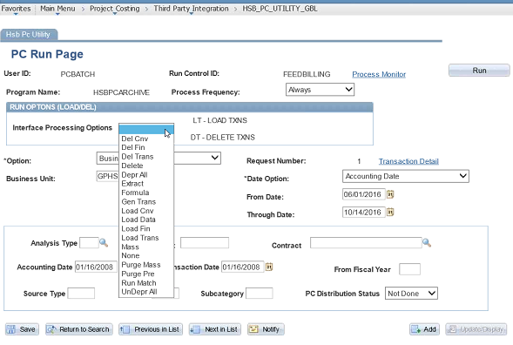

# Queries

# Glossary

PC – Project Costing

PSFT – PeopleSoft

Business Team – HSB Business Finance Team

PSFT Tech Team – PeopleSoft Finance Technical Team

BU – Business UNIT